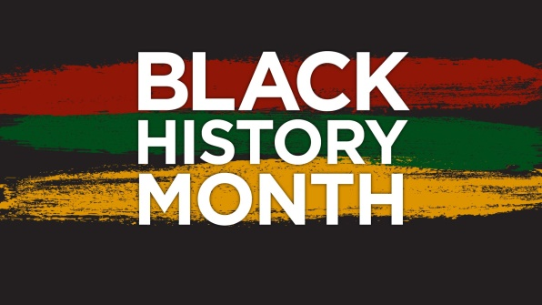

**Key Knowledge I need to understand**

Slavery is where one person is owned by another. A slave is treated as if he or she were a piece of property and is forced to work for nothing for their owners.

Segregation means keeping people apart. In many cases it is a form of discrimination because one group of people is treated unfairly.

Rosa Parks (1913 – 2005)

In 1955, she refused to give up her seat on a bus to a white person. At that time, white people and black people were kept apart in some American states. Her actions changed American history forever.

Martin Luther King Jr (1929 – 1968)

He led the fight for equal rights for black people in America. He didn't believe in using violence to change things. He was famous for his powerful speeches.

Culture is a pattern of behaviour shared by a society, or group of people.

**What’s next?**

BHM – Significant events – Year 4 – The Windrush

**Prior Knowledge**

BHM - Significant people and events – Year 2 – Mary Seacole

**Year 3**

**History Topic: BHM – An introduction to Black History**

**Seamer and Irton CP School – Knowledge Organiser**

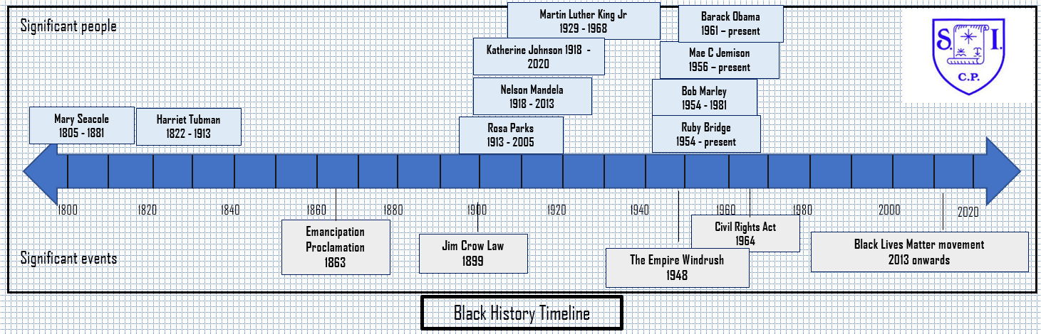

**How I will show what I have learned?**

I can understand the oppression suffered by black people

I can understand how and why people were segregated on the basis of their race

I can retell the events undertook by Rosa Parks in her fight for freedom

I can retell the events undertook by Martin Luther King jr in his fight for freedom

I can celebrate the achievements of black musicians

(Use ‘One Love’ book)

I can celebrate other’s diversity

# (Use Hair Love | Oscar®-Winning Short Film on YouTube)

**Key vocabulary I need to know**

Oppression

[Emancipation](https://www.dictionary.com/browse/emancipation/)

Discrimination

Racism

Segregation

Slavery